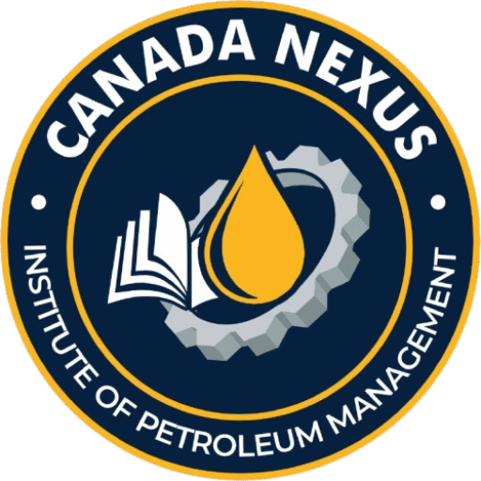
Canada Nexus Institute of Petroleum Management

Specialized Certificate in Project Management in Oil & Gas Industry
Scholarship Application Form

Personal Information
Full Name:
_________________________________________________________
Year of Birth:
_________________________________________________________
Gender:
[ ] Male [ ] Female [ ] Other [ ] Prefer not to say
Nationality:
_________________________________________________________
Contact Number:
_________________________________________________________
Email Address:
_________________________________________________________
Current Address:
_________________________________________________________
_________________________________________________________
_________________________________________________________

Educational Background
Highest Level of Education:
[ ] High School Diploma [ ] Bachelor's Degree [ ] Master's Degree [ ] Other: __________

Field of Study:
_________________________________________________________

Institution Name:
_________________________________________________________
Year of Graduation:
_________________________________________________________

Professional Details
Current Employer/Organization:
_________________________________________________________
Job Title/Position:
_________________________________________________________
Years of Experience in Oil & Gas Sector:
[ ] Less than 1 year [ ] 1–3 years [ ] 4–6 years [ ] 7+ years
Currently working in the oil and gas industry?
[ ] Yes [ ] No
Brief Description of Your Role:
_________________________________________________________
_________________________________________________________
_________________________________________________________

Statement of Interest (Maximum 300 words)
Please outline your interest in the course, your career goals, and how this scholarship will support your professional development.
_________________________________________________________
_________________________________________________________
_________________________________________________________
_________________________________________________________

Upload Documents
- Curriculum Vitae (CV)
- Statement of Interest

Declaration and Consent
I certify that the information provided is accurate and complete to the best of my knowledge. I understand that submitting false information may disqualify my application.
Signature: ___________________________ Date: _________________________

Note: The application deadline for 2026 will be evaluated individually. Kindly send your completed application to admissions@nexuspetroleuminstitute.ca. You should receive a decision within 14 business days after submitting your application. Thank you.

